## ADDI

## Prerequisite for project with version

* Java 1.8
* Orient DB 3.0.15 or Any Latest Version
* Apache Maven 3.6.0

## Steps for project execution

1. OrientDB installation

* Download Orient DB latest version through the link [https://orientdb.org/download](https://apac01.safelinks.protection.outlook.com/?url=https%3A%2F%2Forientdb.org%2Fdownload&data=02%7C01%7Cpiyush.c%40hcl.com%7C0afe9f58bba74b3f501208d69e090585%7C189de737c93a4f5a8b686f4ca9941912%7C0%7C0%7C636870158913489770&sdata=ZImcSco4GvpegerSAk%2FMvS4%2BEixC%2BqmNMLjNHPonxvg%3D&reserved=0)

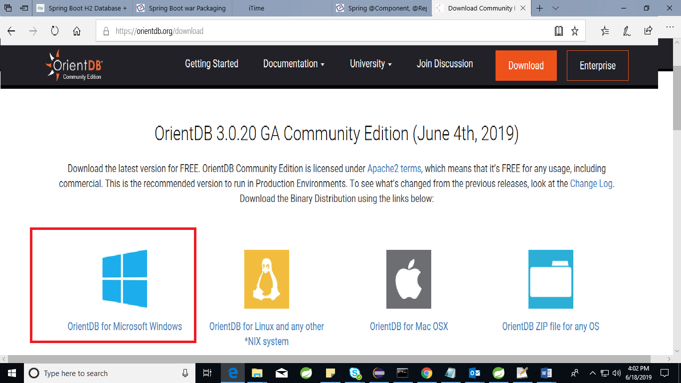

* Click on the “Orient DB for Microsoft Windows”. It will start download the zip.
* Extract the downloaded OrientDb and switch to bin directory.

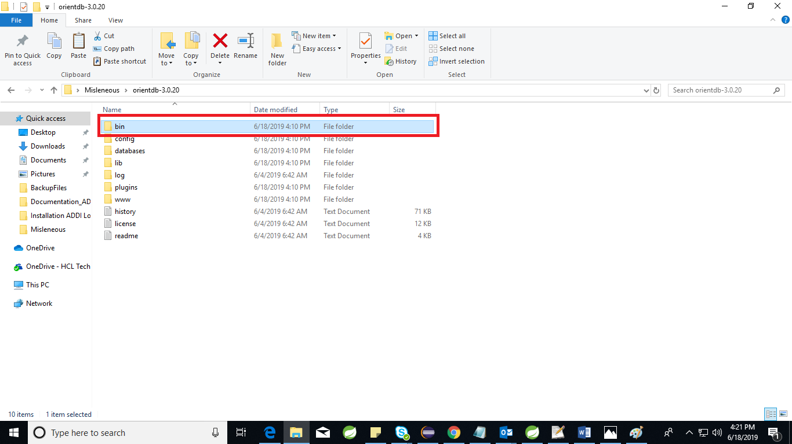

* Execute the “**server.bat**” file in command prompt.
* 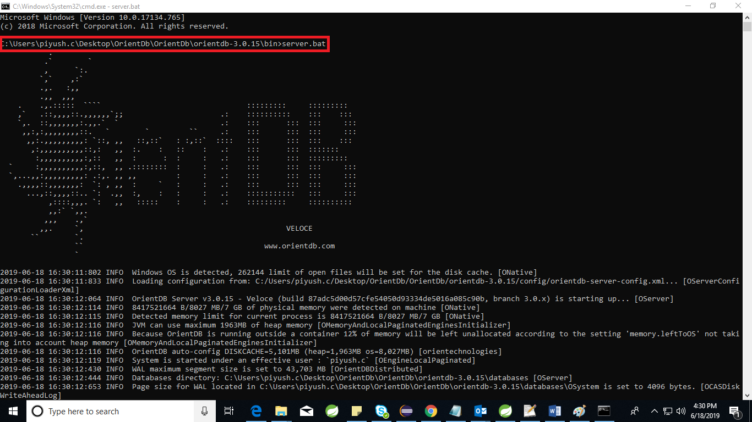
* Set orient DB password as “**admin**”

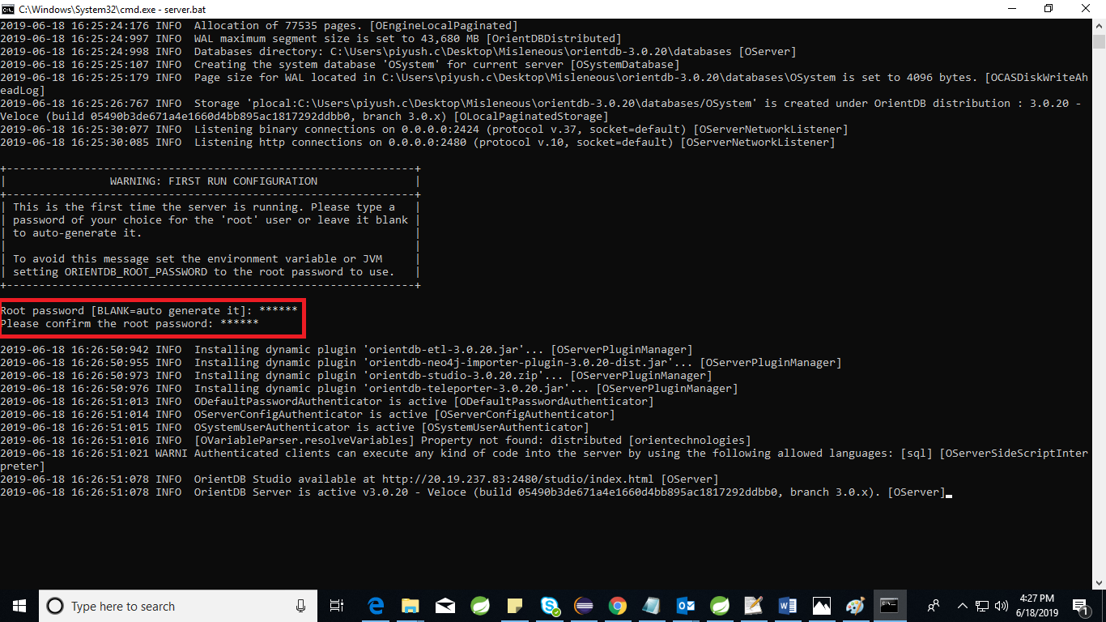

* <http://localhost:2480/studio/index.html#/> refer this link to open home page.
* Click on “**NEW DB**”
* Create new DB with name “**ADDIdb**” and set username “**root**” password “**admin**”

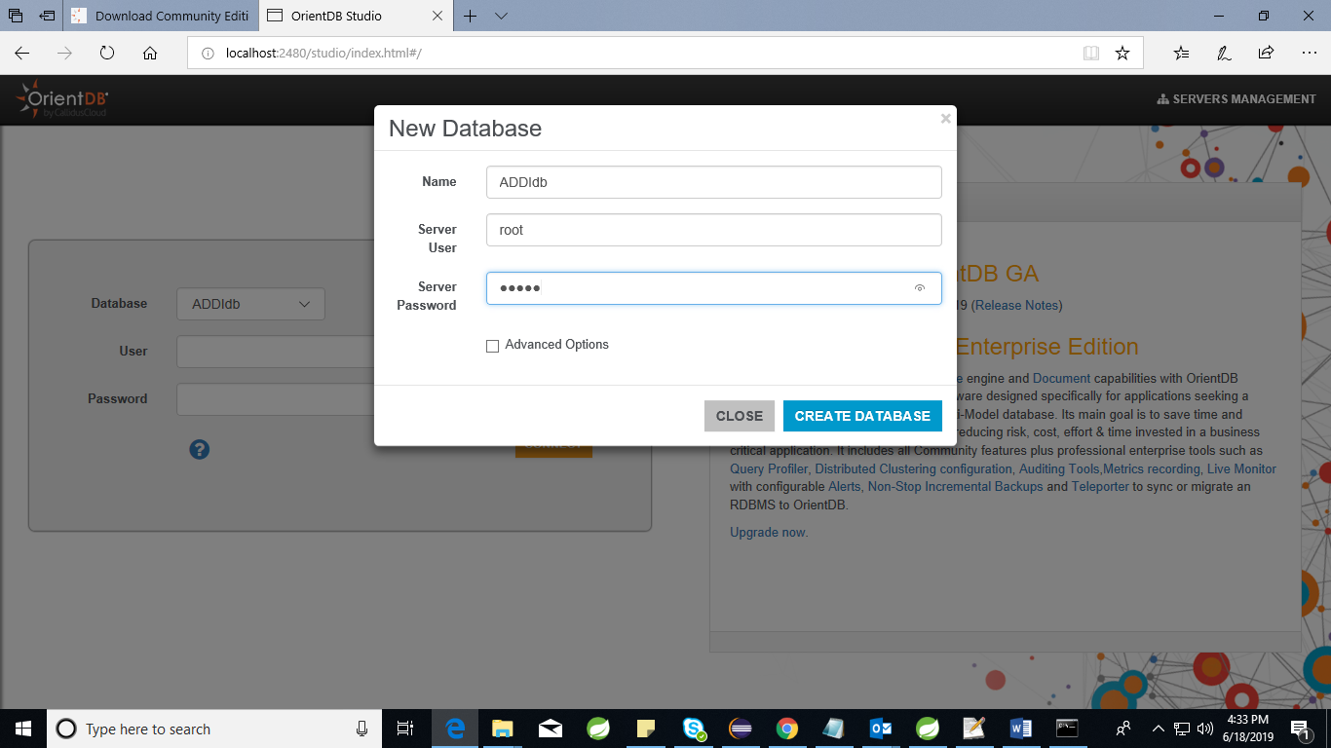

1. Execution of the ADDI application

* Create new folder with name ADDI inside local disk ‘C’ directory to keep “**ADDI-0.0.1-SNAPSHOT.jar**”.

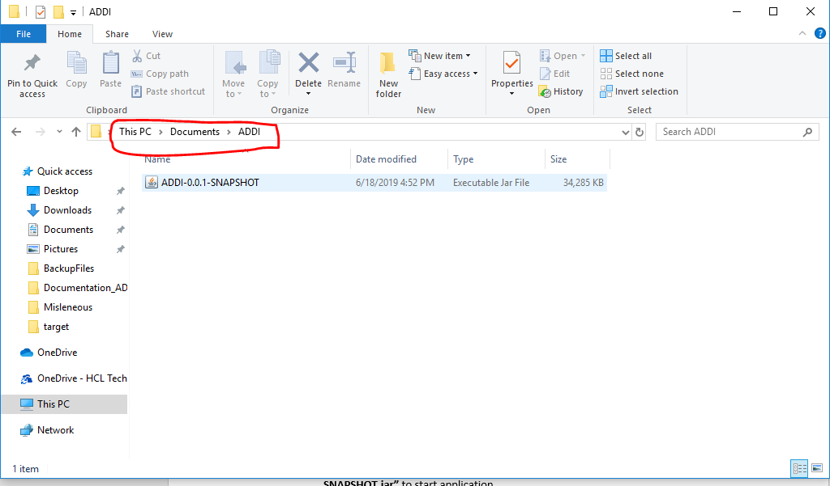

* Keep data files inside ‘C’ directory with any name.

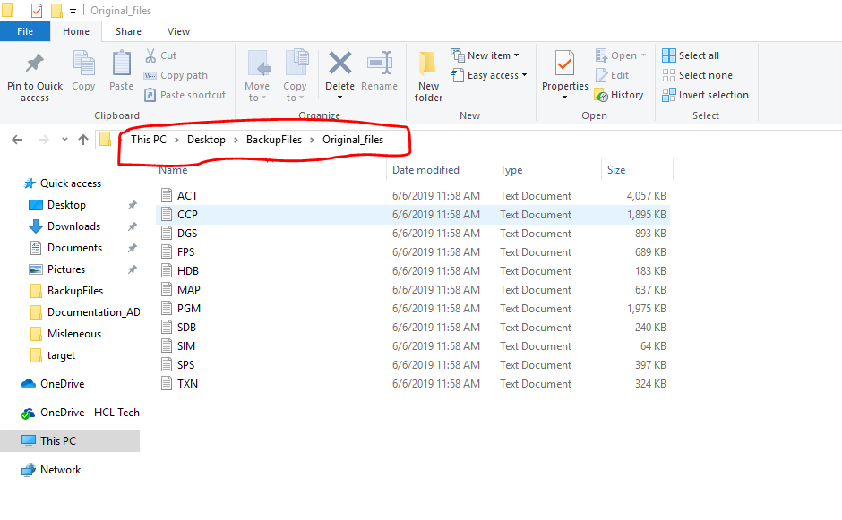

* Execute the command **“java -Ddatafiles=<path to datafiles> -jar ADDI-0.0.1-SNAPSHOT.jar”** to start application.
* Refer the below image to execute command



1. End Urls

* <http://localhost:9090/hogan-connector/batch/data/files> click on this url to save the datafiles into Orient database.

Note: *It takes approx. 40 to 50 min to save all the datafiles.

*Make sure “server.bat” should be running before executing above url.

* To execute functionality and services of ADDI please refer below link <http://localhost:9090/swagger-ui.html#/>